Network Load Balancer with ORM Stack

Contents

1.Introduction 3
2. Workflow diagram to deploy the stack 3
3.Create Stack (external public nlb) 4
4.Create Stack (internal private nlb) 5
4.Plan the Job 8
5. Apply the job 9
6.Verify in the Console 11
7. Destroy the Stack 12

1.Introduction

Load Balancers provide automated traffic distribution from one entry point to multiple servers reachable from virtual cloud network (VCN). They improve resource utilization, facilitate scaling, and help ensure high availability.

Pre-request:

1. Compartment OCID to deploy Public Network Load Balancer
2. Region where the Network Load Balancer is deployed
3. Public subnet OCID to deploy Public Network Load Balancer

2. Workflow diagram to deploy the stack
Below diagram shows how the Terraform Artifact are applied in the OCI. While creating a ORM stack, using terraform deliverables Init, Plan and Apply is the flow to provision the resource in the OCI. We can have the deliverables in any of below.
- GitLab/GitHub Repo
- Bitbucket
- Can be in folder/.zip in the local disk
- Object Storage Bucket
- Can be in compartment
- Oracle provided Template
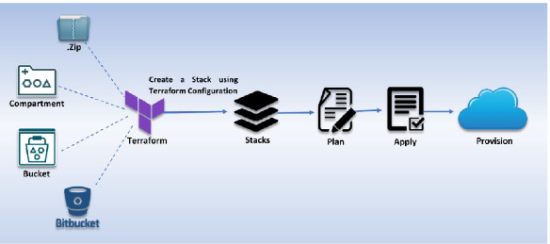

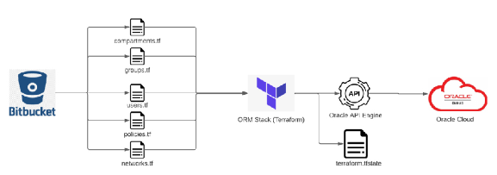

3.Create Stack (external public nlb)

Go to OCI Console Developer Services Resource Manager Stacks select the compartment Create Stack
My Configuration Folder Browse

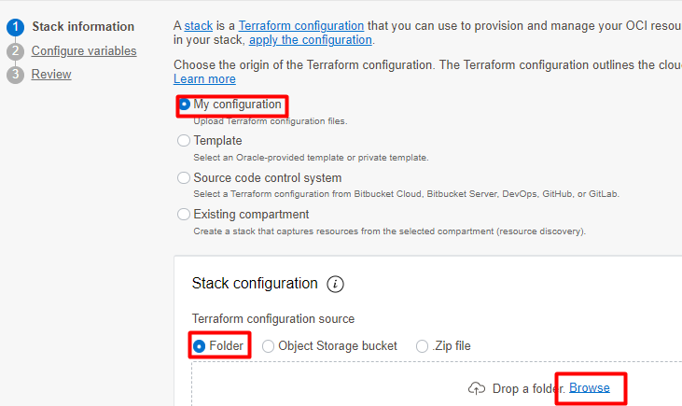

Select the “Network_LoadBalancer ”nlb” folder that contains the terraform and yaml Upload
For Public Loadbalancer select the working directory as nlb/np_external_public_nlb

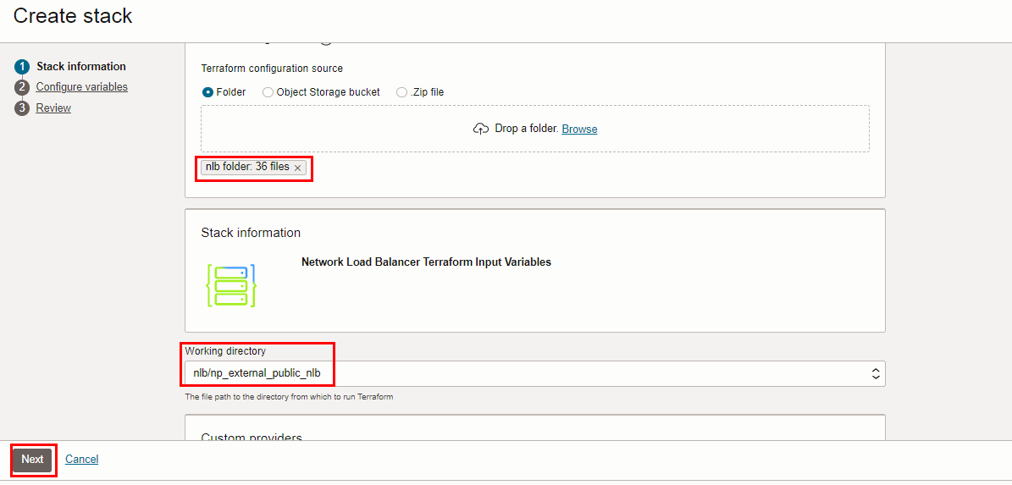

Click “NEXT”

4.Create Stack (internal private nlb)

Select the “Network_LoadBalancer ”nlb” folder that contains the terraform and yaml Upload
For Public Loadbalancer select the working directory as nlb/np_internal_private_nlb

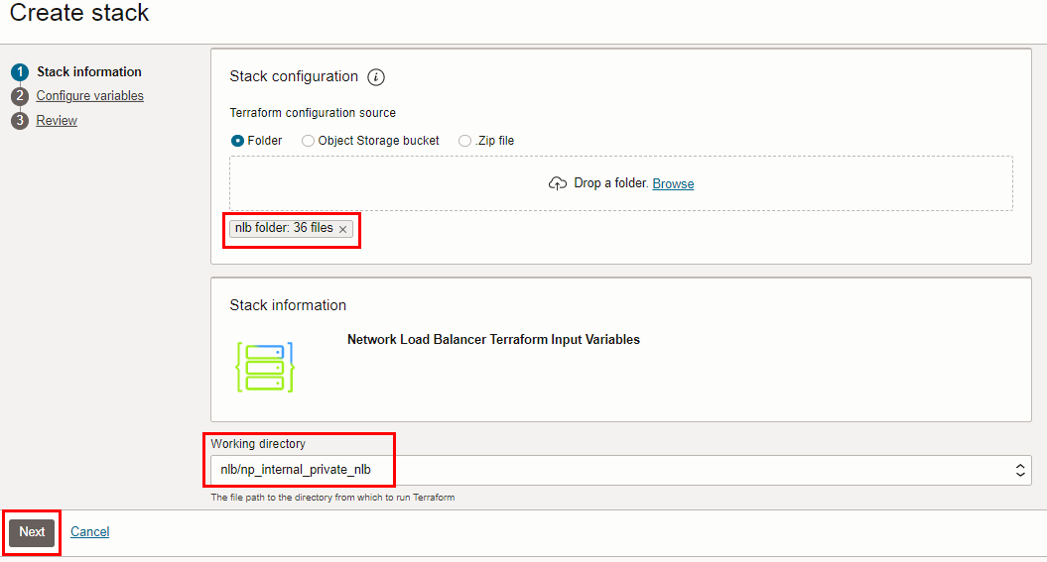

Click “NEXT”

Select the parameters as per the below screen,

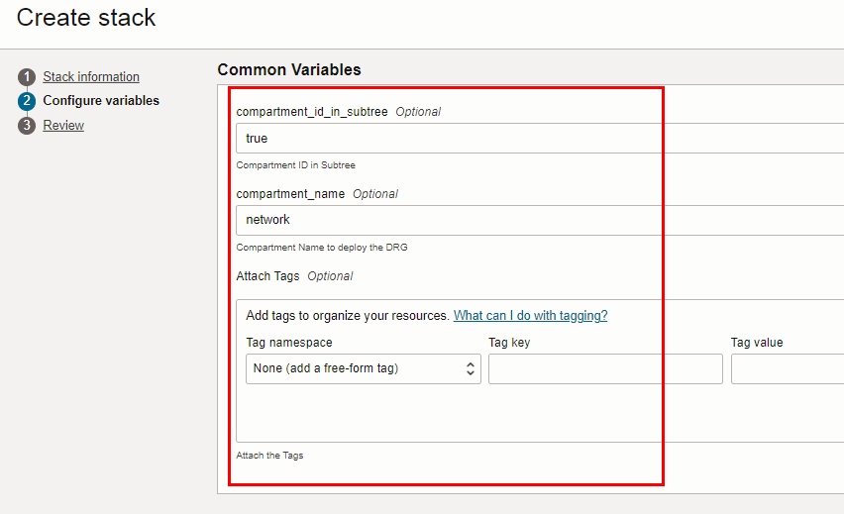
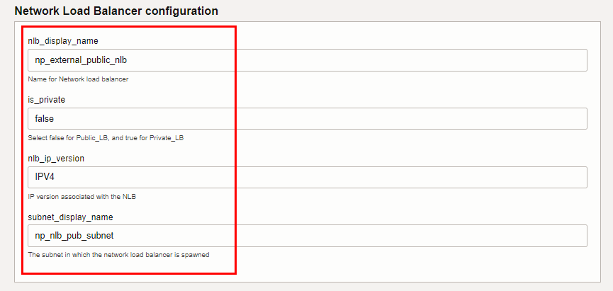
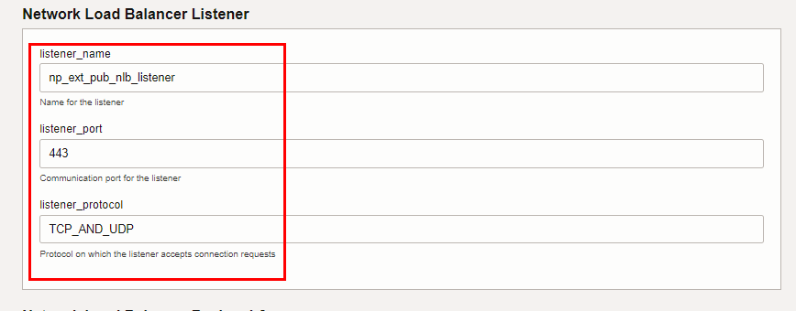
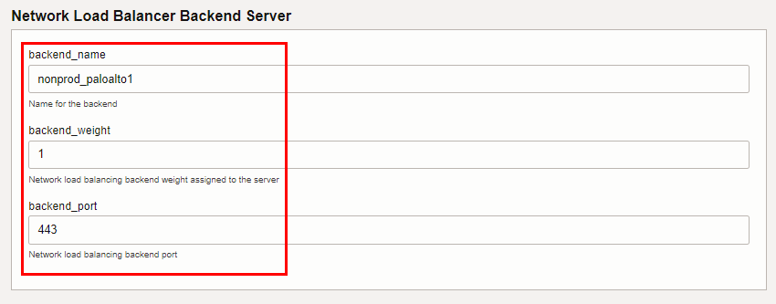
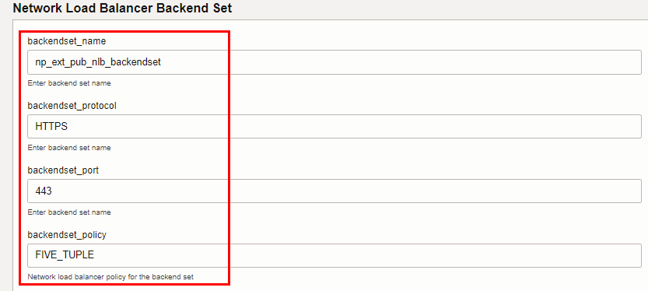
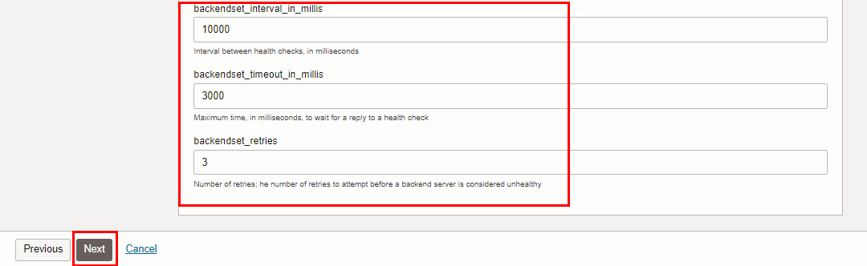

Click “NEXT” Click “CREATE”

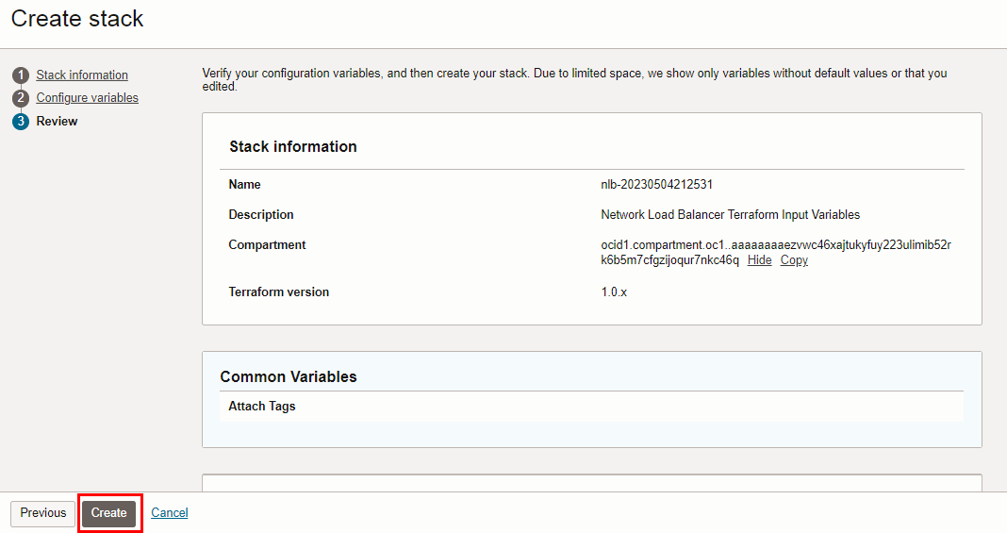

4.Plan the Job

Click the “Plan”
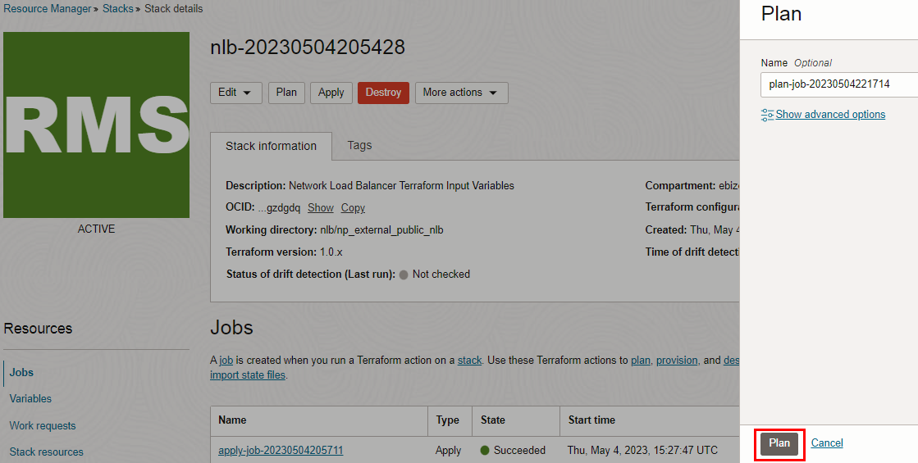

Verify the Plan is successful.
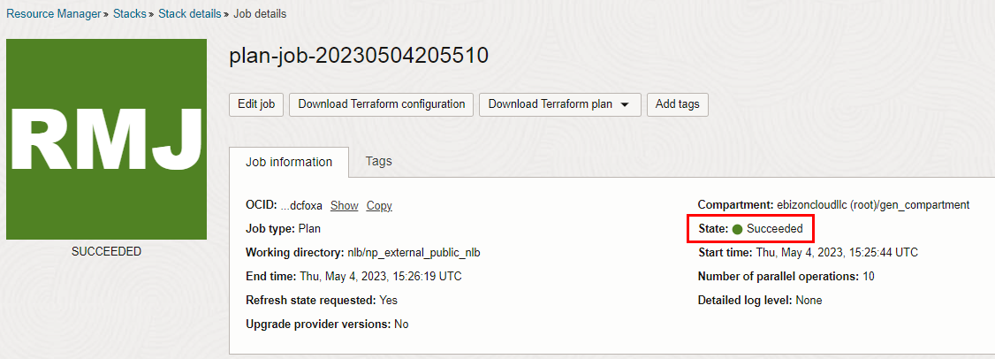
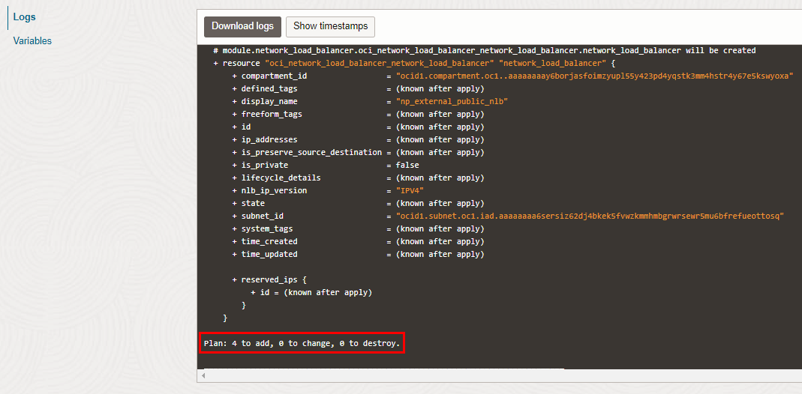

5. Apply the job

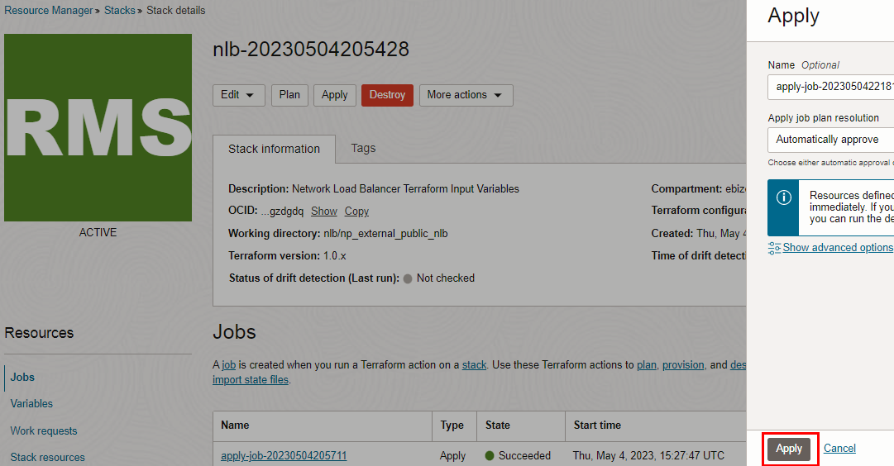

Verify the Apply is successful.

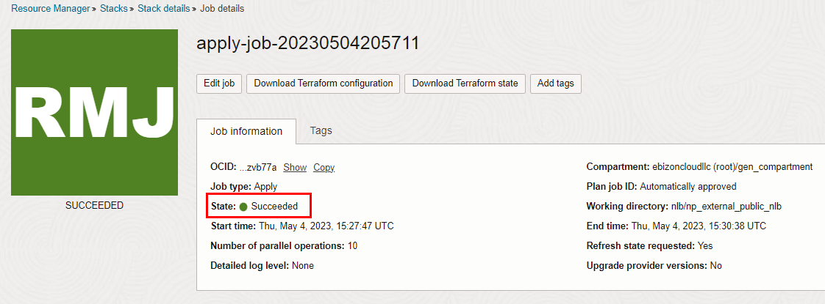

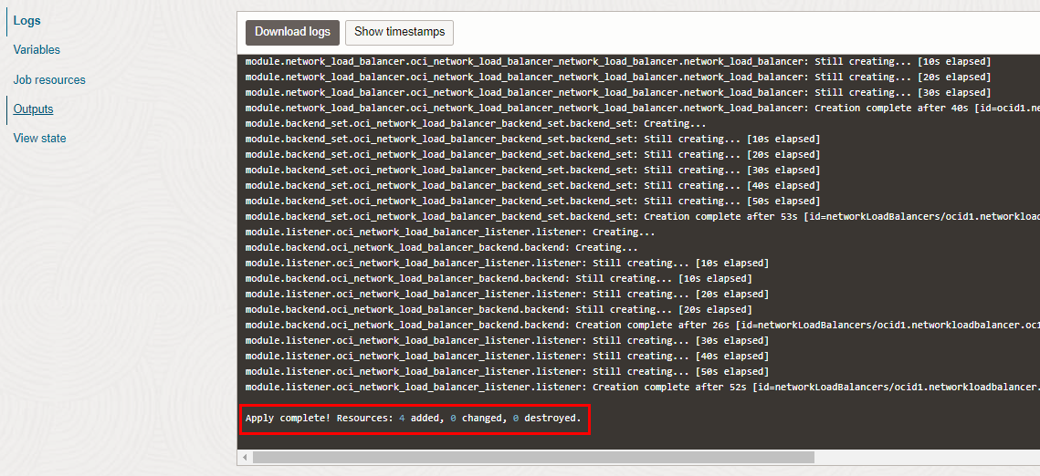

6.Verify in the Console

Go to OCI Console Networking Load Balancers

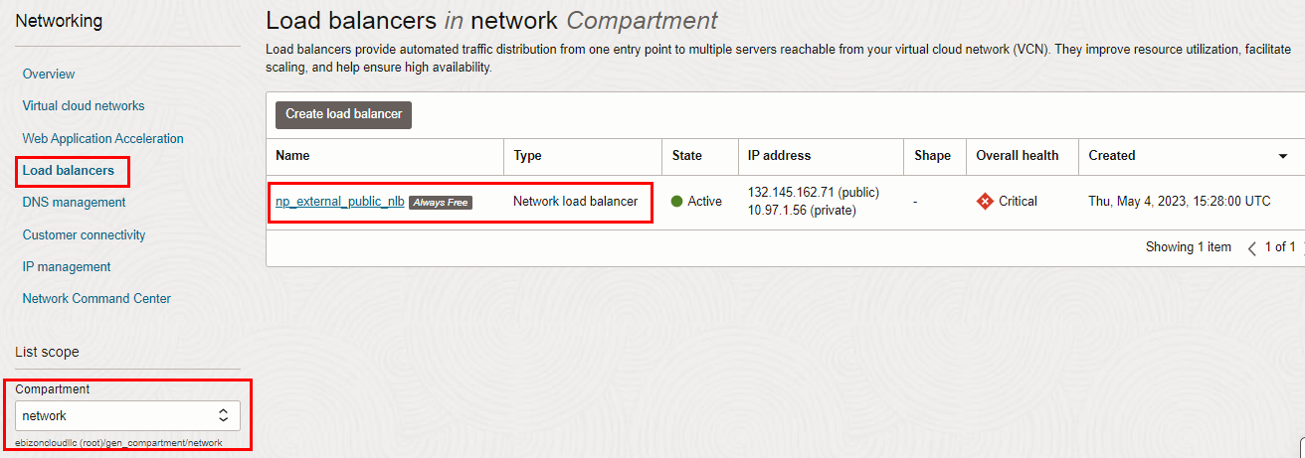
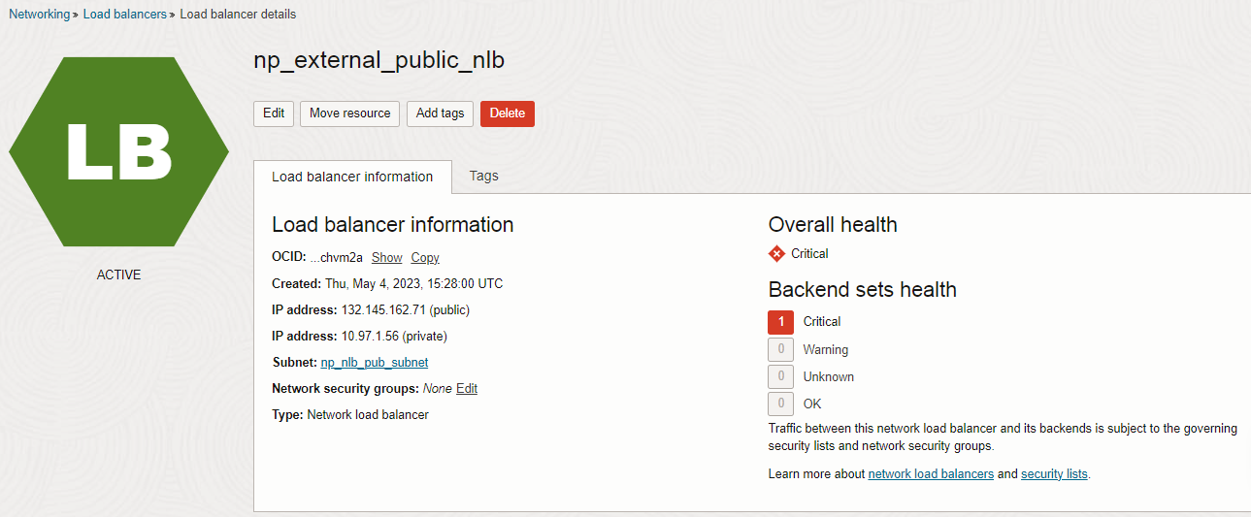

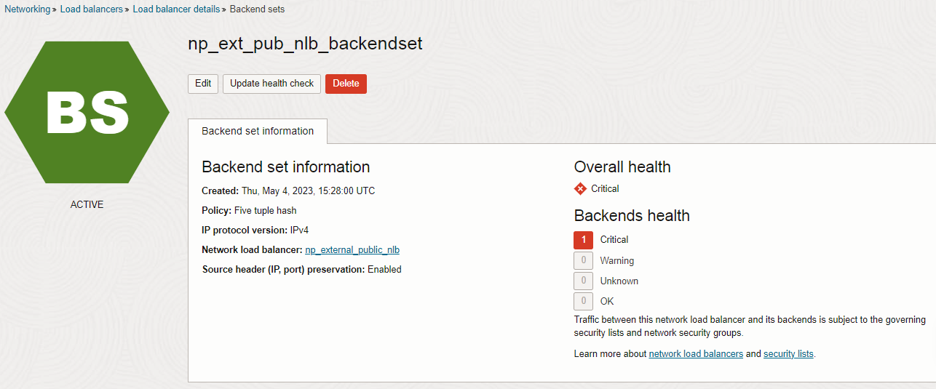
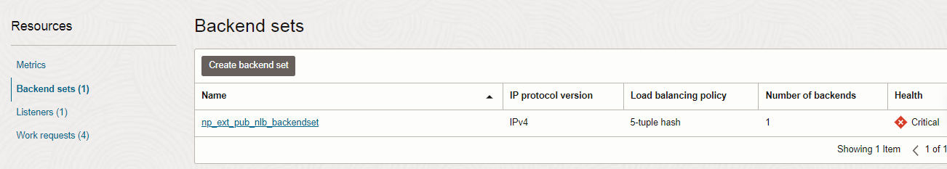
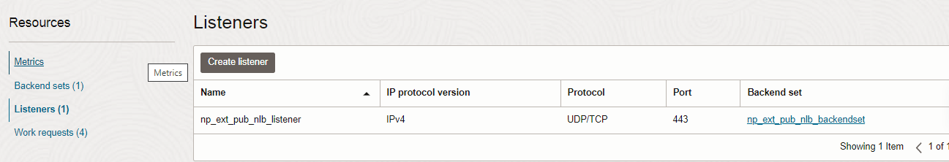

7. Destroy the Stack

